* **Title of the seminar:** IPR: IMPORTANCE AND LIMITATION IN COLLEGE LEVEL.
* **Type of the Activity:** Seminar on Intellectual Property Rights
* **Organizing Department/ Committee:** SEMINAR SUB-COMMITTEE
* **Date of the Activity:** 22-05-2023
* **Number of participants:** 66
* **Speakers:** DR. JAYANTA GHOSH, Head & Research Fellow, CRSGPP, West Bengal National University of Juridical Science
* **Flyer**:

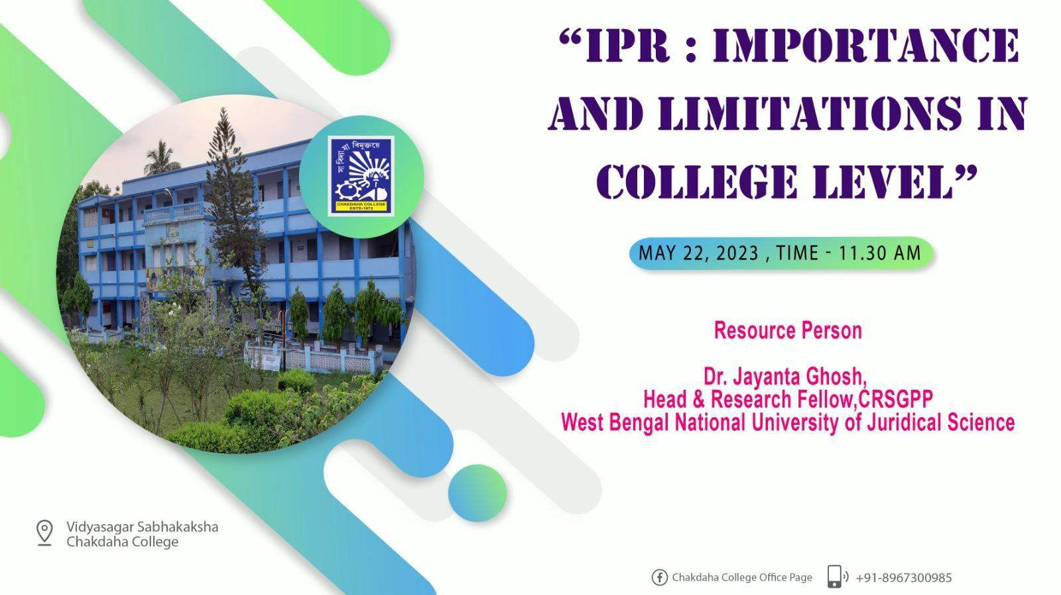

* **Outcome of the seminar**:

A One Day State Level Seminar on “IPR: Importance and Limitations in College Level” was organized by Chakdaha College on 22.05.2023. It started with the welcome address by Dr. Swagata DasMohanta, Honourable Principal of Chakdaha College. Dr. Jayanta Ghosh, Head & Research Fellow ,CRSGPP, West Bengal National University of Juridical Science, was the Resource Person in the said seminar. He talked to the staff of the College at length about Patents, Trademarks, R sign, Intellectual Property Rights, its importance in various fields with special emphasis on its importance in academia, in the administration of an institution like college, the need to have the college’s own IPR policy etc. The target audience was glued to his simple, informative yet informative delivery as it was replete with everyday experiences with which they could easily identify themselves. The seminar ended with a vote of thanks by Dr. Sarbajit Paul, Head, Department of Commerce, Chakdaha College. The seminar was a grand success.

* **Attendance:**

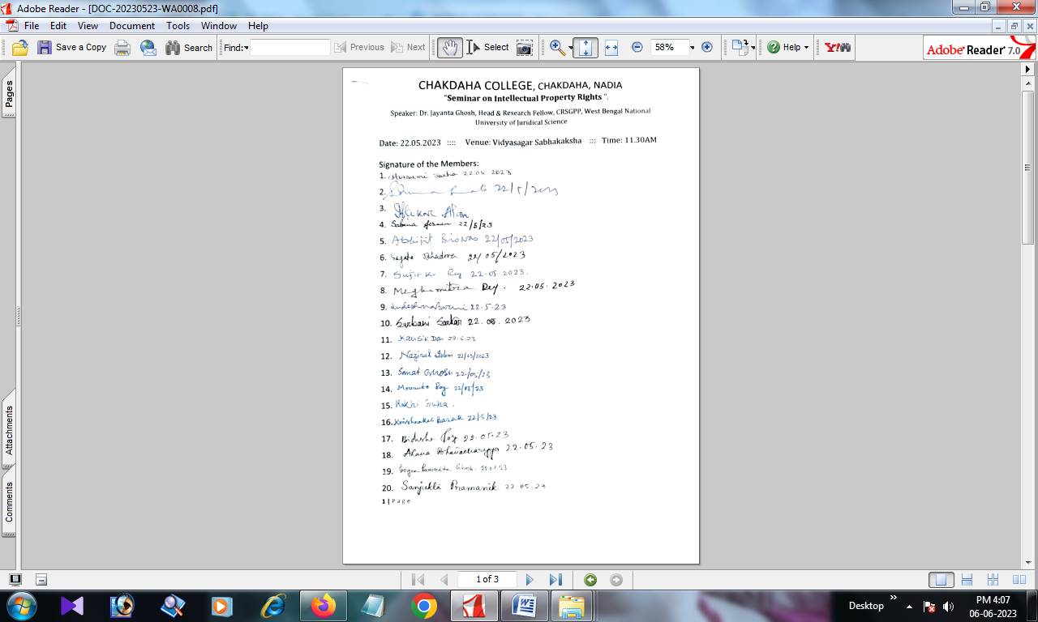

* **J. Photograph of the Seminar:IPR: IMPORTANCE AND LIMITATION IN COLLEGE LEVEL**

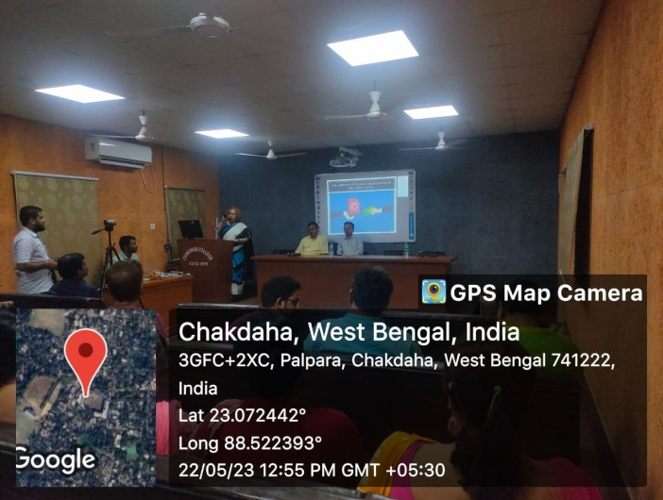 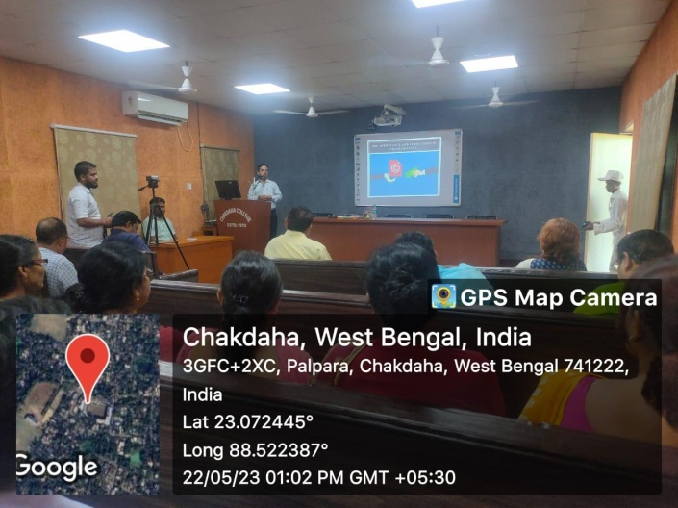

Principal Madam addressed the Inaugural Speech Dr. Jayanta Ghosh addressed his speech

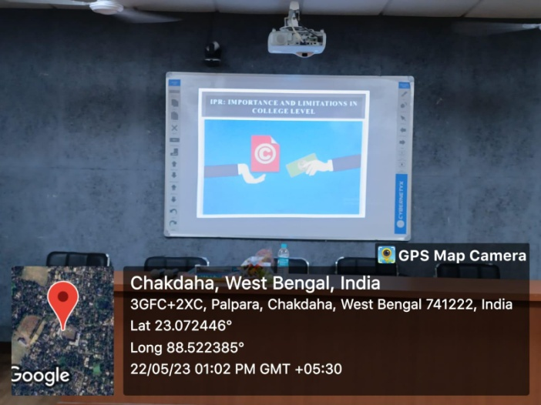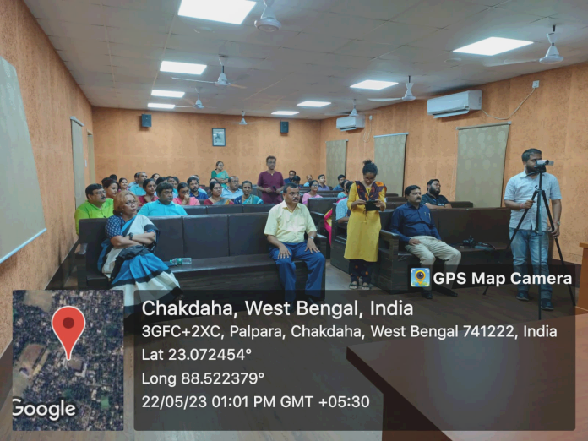

Presentation of Dr. Jayanta Ghosh Audience of the seminar “IPR: IMPORTANCE

AND LIMITATION IN COLLEGE LEVEL”

**Relevant Web Link:**

<https://www.facebook.com/chakdahacollegeoffice/posts/pfbid06nu4ZpBWEJX11HG5511UAnMWWaAom7Z26WfLHfsv97BWwofgpEWeG3acLmVdHEZCl>

<https://www.facebook.com/chakdahacollegeoffice/posts/pfbid0388SDRGFAWTSW8KxUaX8uczD9NqJS9TKBz2Dfpo9PvPzgmJytnujssvBbRx8X9vLjl>